Finima Nature Park Management Report for Week 8: (February19th –23rd2017)

- Highlights:
- General anti-poaching patrol and biological monitoring was conducted round the park and observation was reported, (no one was arrested). Troops of Mona monkey, Green snake, birds, crabs, Cobra, Beetles, butterfly, skink, Dragonfly and Monitor lizards were sighted in the park.
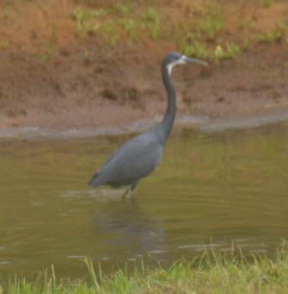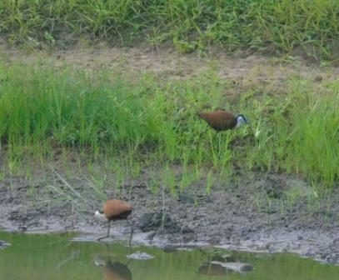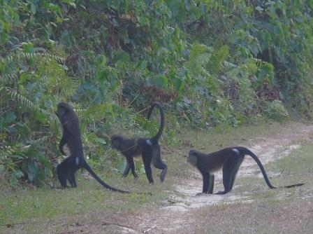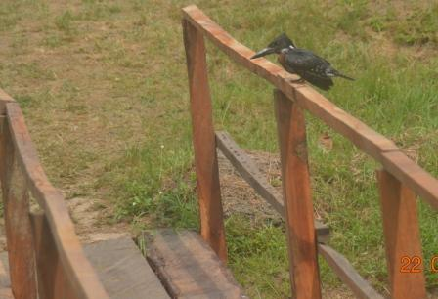Fig. 1, 2, 3, & 4 shows photos of Western Reef Heron, African Jacana, Mona Monkey, and Giant Kingfisher sighted during our Biological monitoring patrol.
- Outreach & Engagement: As a follow up in the School Conservation Clubs.Ibi-Tamuno School visited during the week with 32students and 1Teacher.
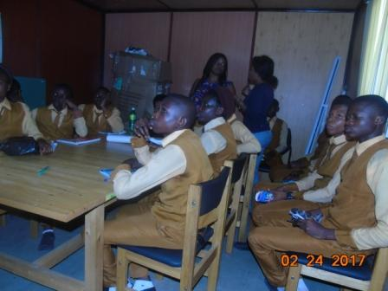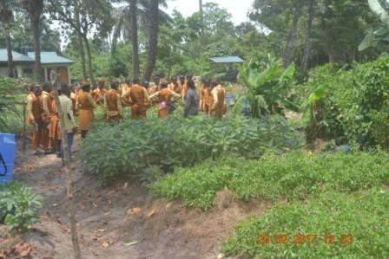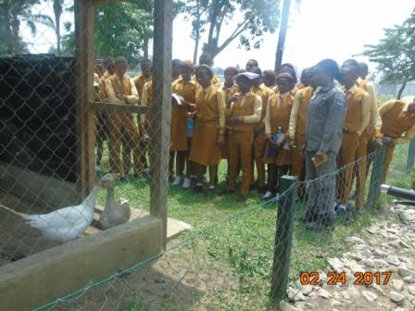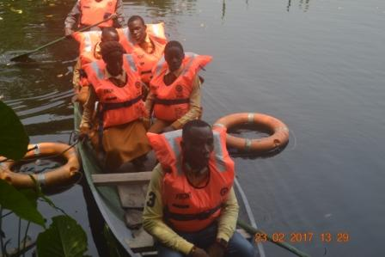Fig. 5, 6, 7 & 8 shows Cross section of Ibi-Tamuno School Pupils visit during the week
- Ecotourism: Visitors were conducted round the Park.
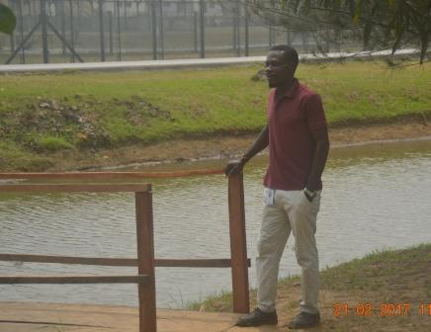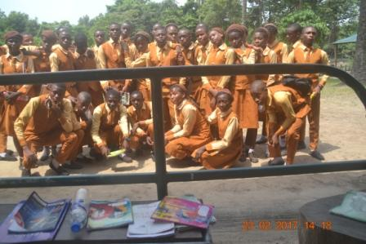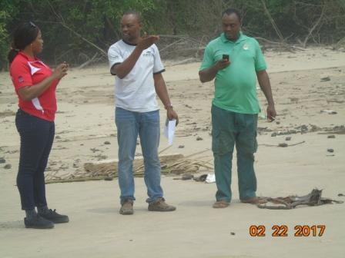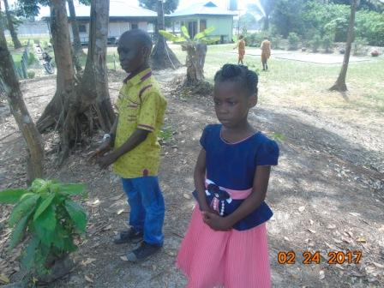Fig. 9, 10, 11 & 12 shows Cross section of visitors that visited the Park during the week
- Tidiness & Cleanliness: Tidiness of the Board walk and other park facilities is in progress, sweeping of board was done. Trail inspection was also carried out during the week, two handrails were damaged and this has since been replaced along the first walkway.
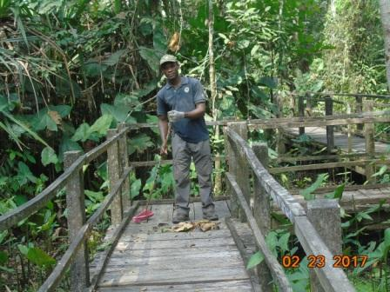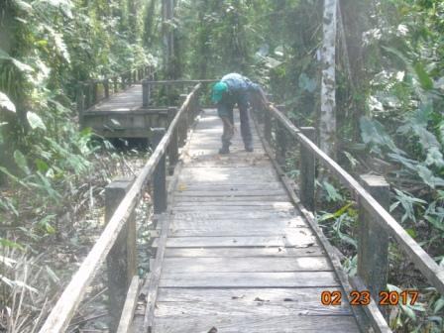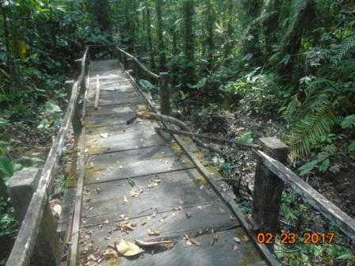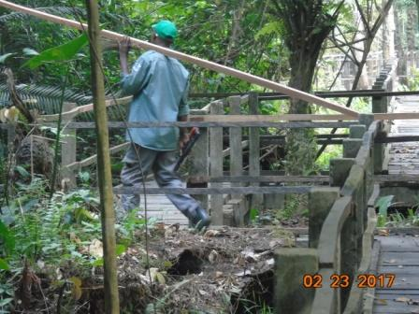Fig 13, 14, 15 & 16 shows Park Guards performing their daily routine job along the walkways
Coastal erosion & Encroachment: Observation shows that siltation and deposition of debris along the shoreline still persist. Monitoring of the three points ear-marked for measurement still remain same with last week; coastal area measurement from Ship Wreck is 120meters away from the Sea, from Hippo creek is 80meters while from Almond Tree is 70meters respectively.
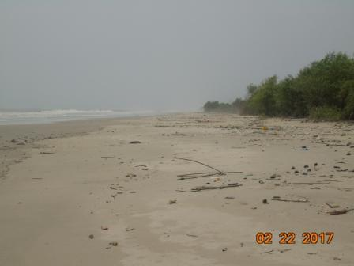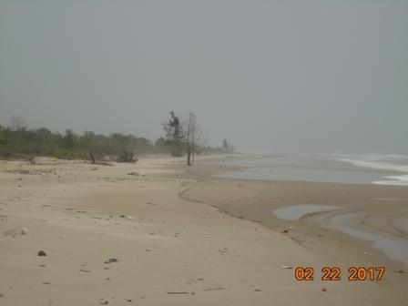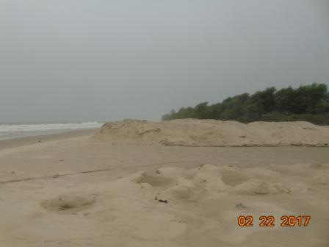Fig 17, 18, 19 & 20 shows photos of impact of coastal erosion and encroachment at the shoreline
Others: The HSE/1 (Dr.Chidi Ikocha) and his team paid a courtesy visit to inspect the project deliverables; he visited the FNP Resources Centre to take a look at the facilities, and the first walkway to inspect the retouch of the Ludo floor games.Mr. NdukakuOhaeri also came for HSE walkabout inspection of Park facilities, his observations were noted and corrective actions will be followed up.
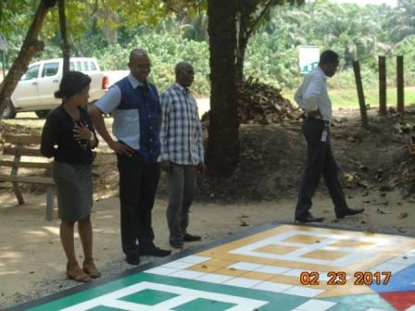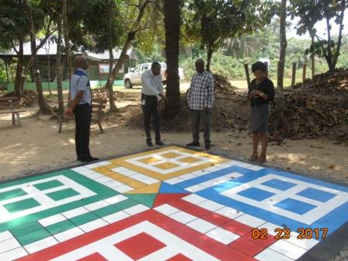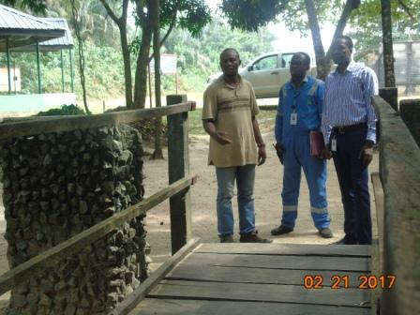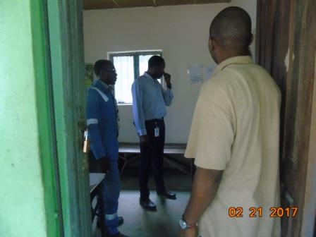Fig. 21, 22, 23 & 24 shows NLNG HSE/1and Team during the courtesy call at the FNP inspecting the floor games and Mr. Ohaeriduring HSE walkabout inspection of Park facilities
Others activities carried out during the week include - removal of barriers from the pond, watering of plants at NLNG Roundabout and watering of just concluded reforestation of degraded area within the Park. Housekeeping of the Park premises, completion of the retouch of Ludo game, and sand filling of the pothole area of the Park access road along Lighthouse Sibekiri was also carried out by the Park Rangers.

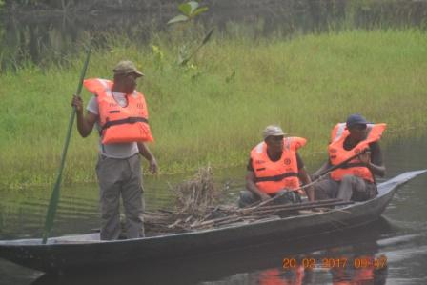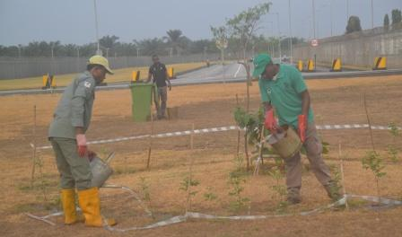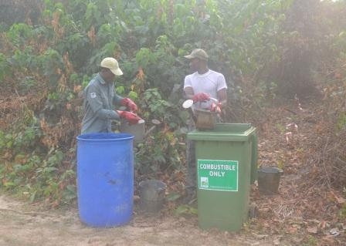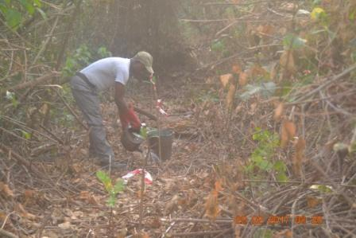Fig. 29, 30, 31 & 32 shows Park Rangers and Guards removal of barriers in pond, watering of the Plants at NLNG Roundabout and Just concluded reforestation of degraded area of Park respectively
- HSE:
No incident occurs during the week.
- Update on number of Visitors:
- Total number of visitors for the week =50
- Total number of visitors from January 2017 to date =1019
Week | Date | Nr. of Visitors | YTD
1 | 01/01 - 07/01 | 223 | 223
2 | 08/01 - 14/01 | 9 | 232
3 | 15/01 - 21/01 | 23 | 255
4 | 22/01 - 28/01 | 117 | 372
5 | 29/01 - 04/02 | 66 | 438
6 | 05/02 - 11/02 | 104 | 542
7 | 12/02 - 18/02 | 427 | 969
8 | 19/02 - 23/02 | 50 | 1019

